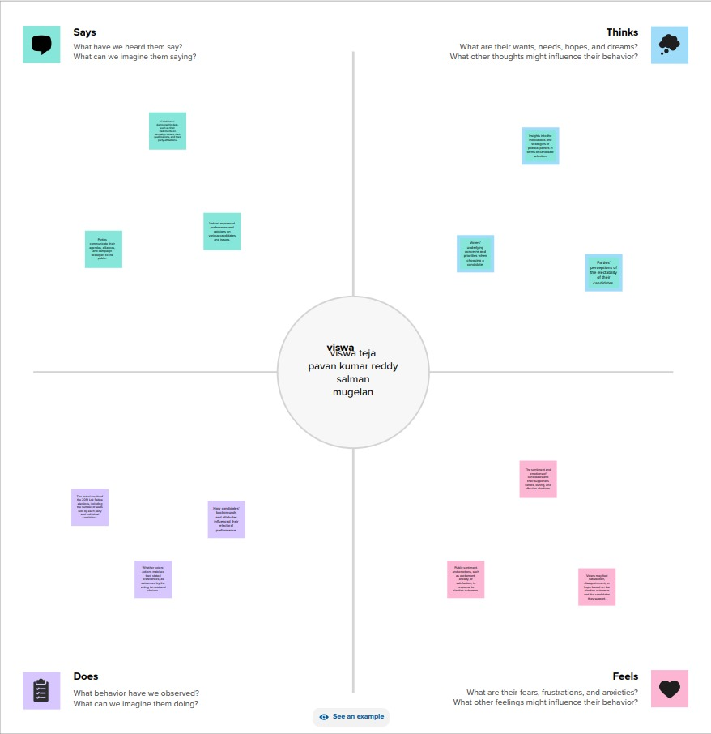
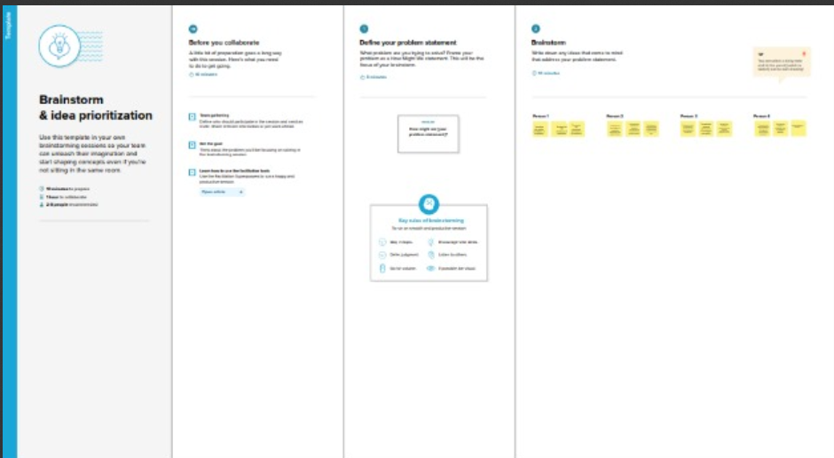
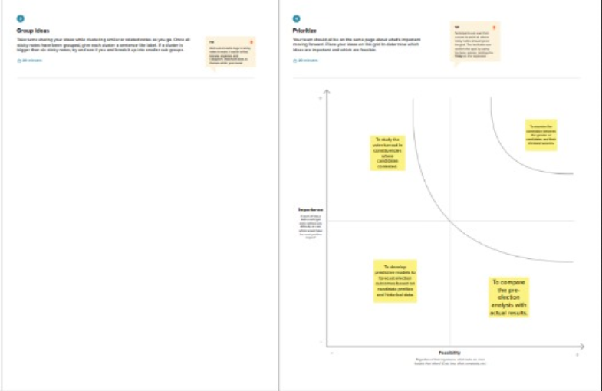
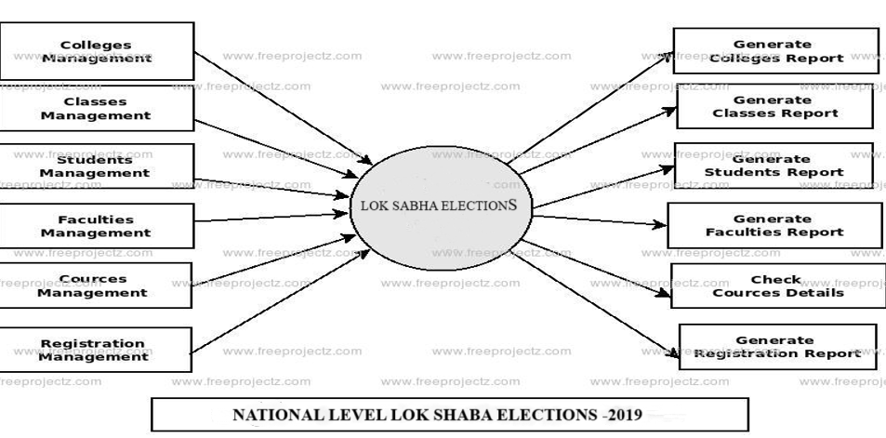
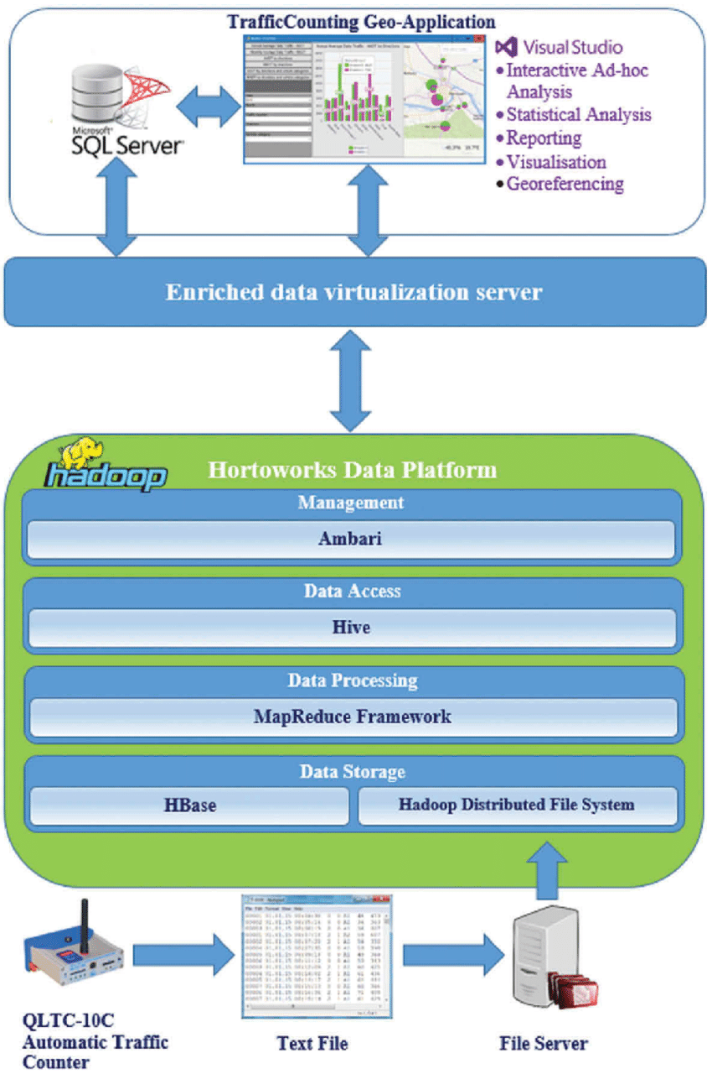
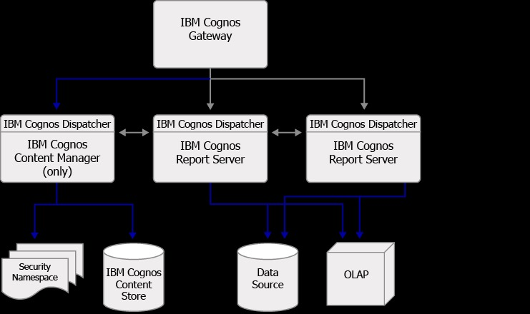
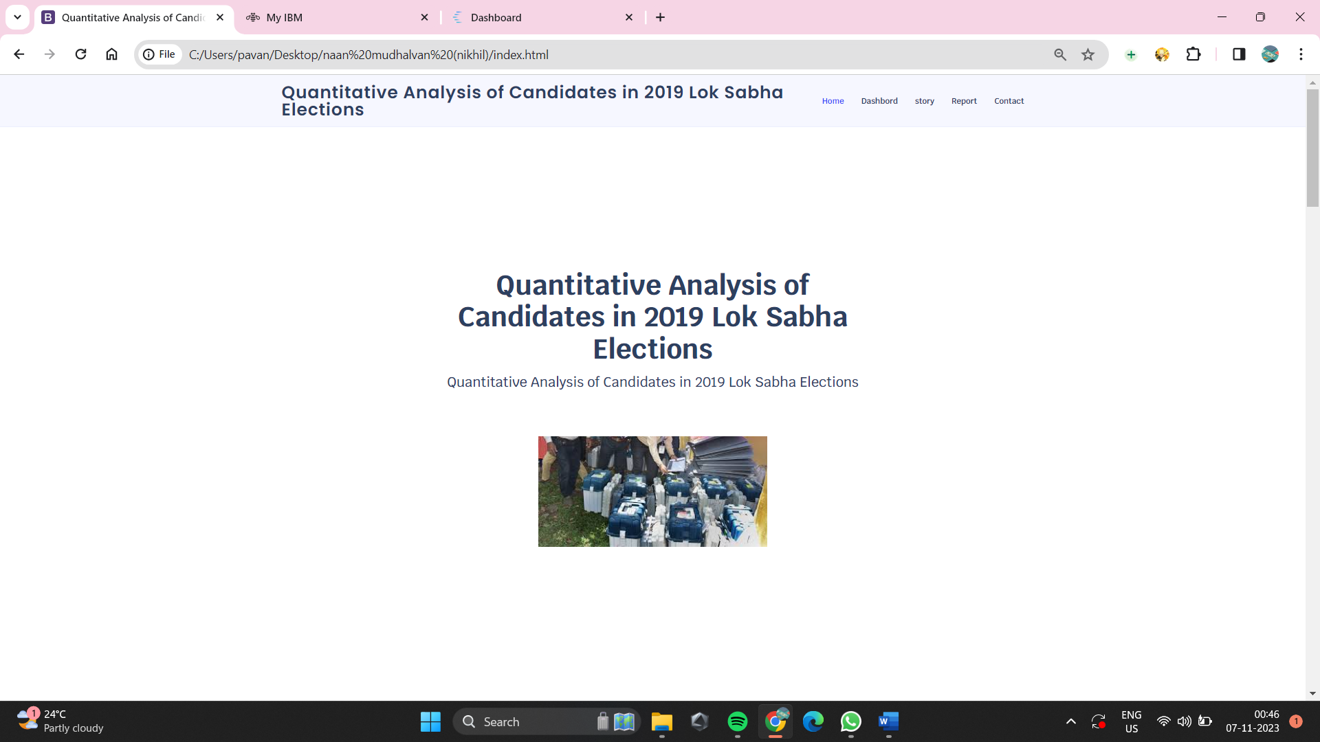
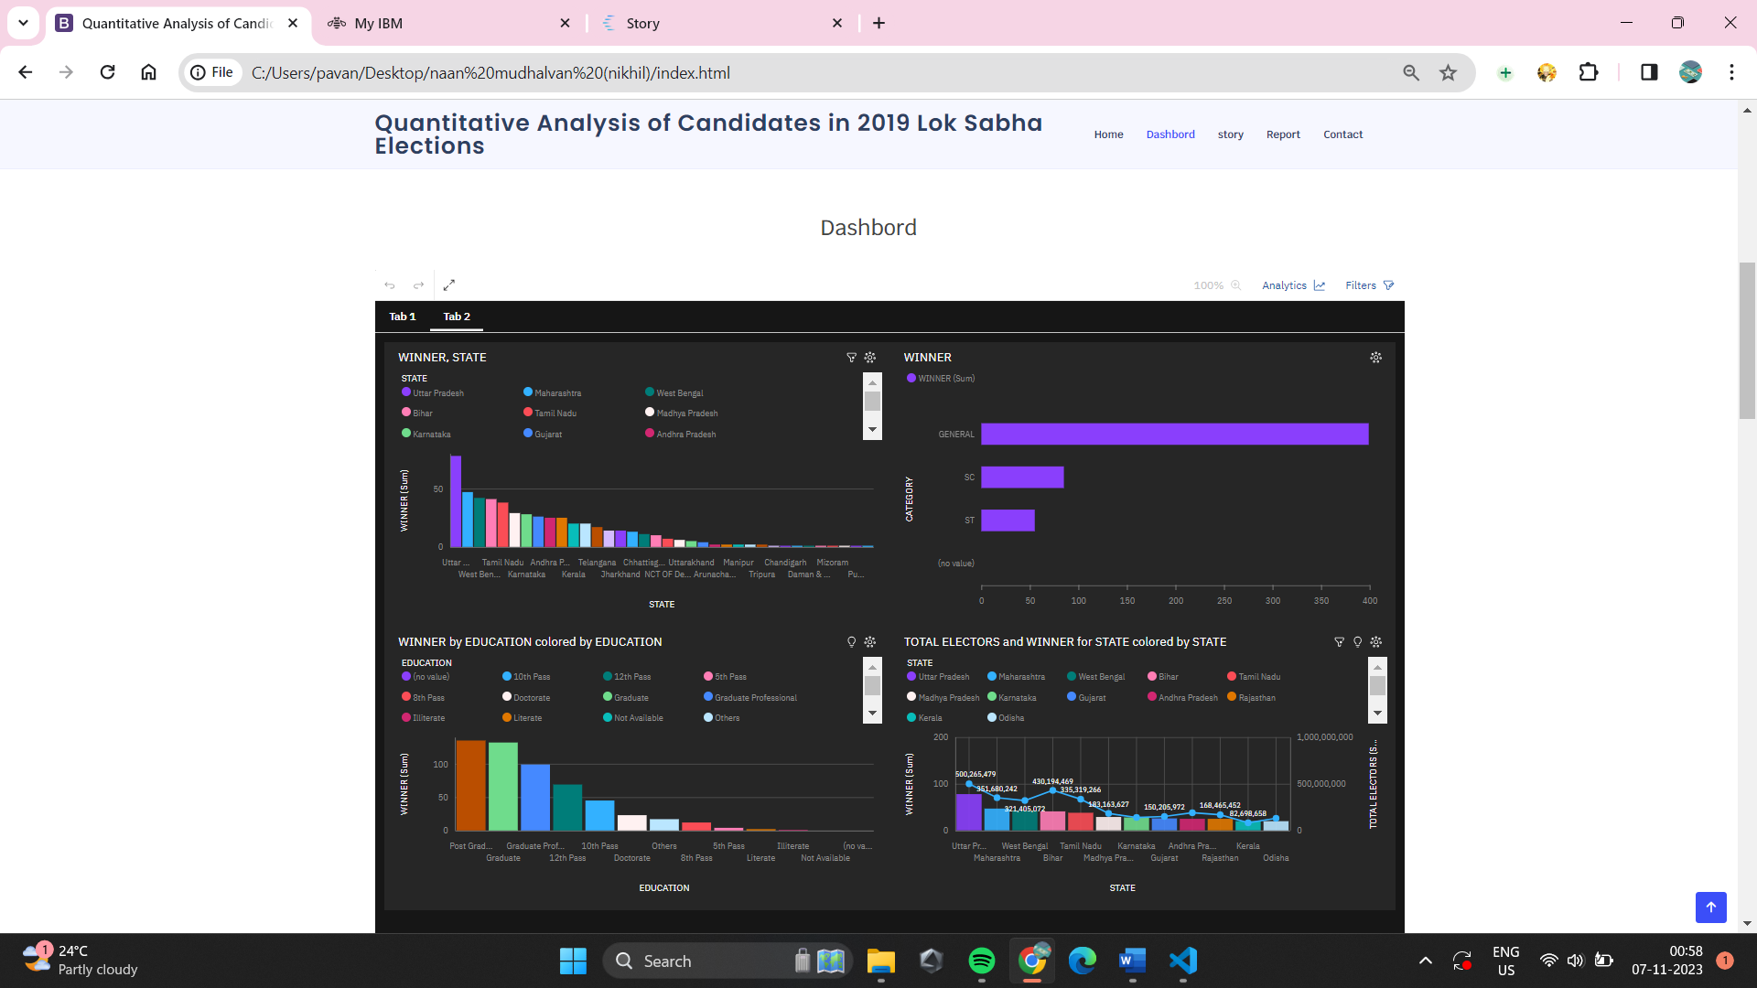
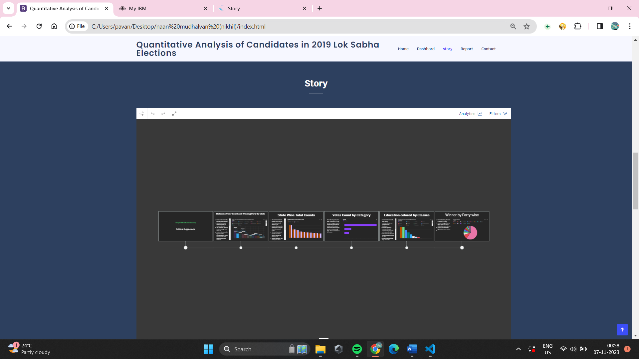
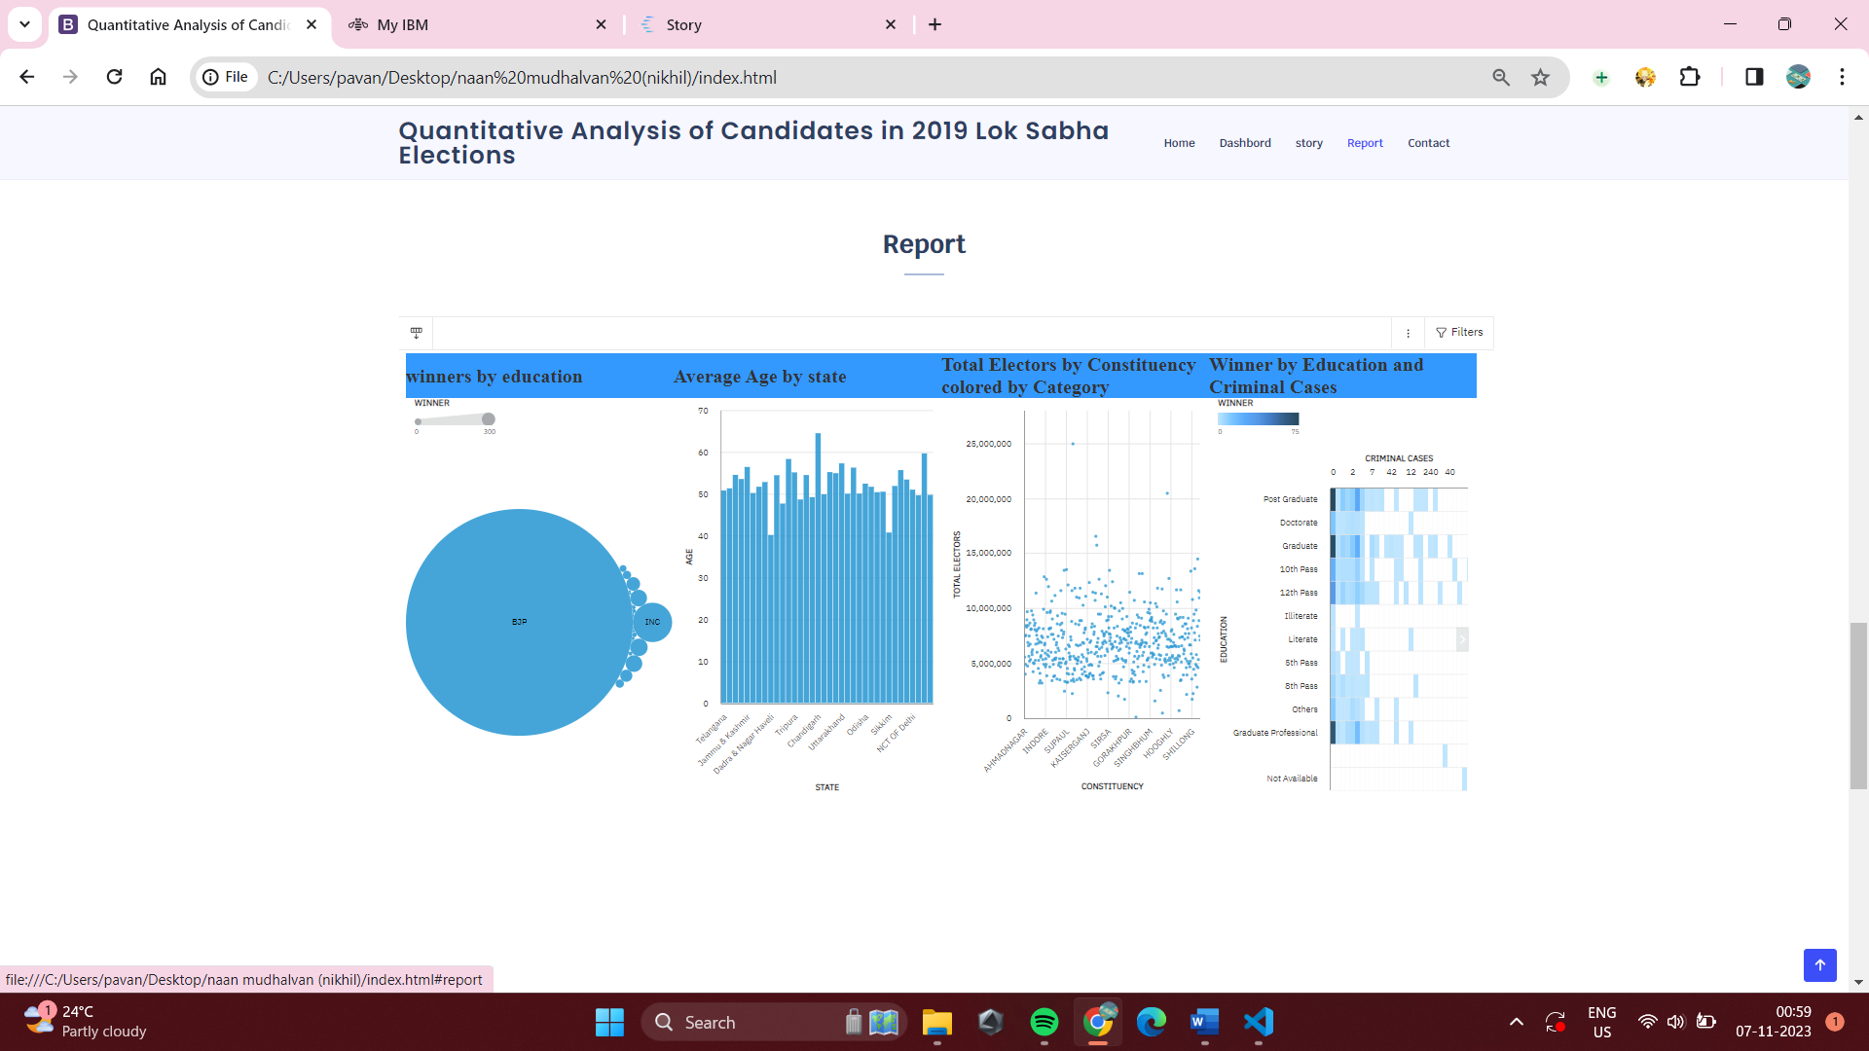
Quantitative Analysis of Candidates in 2019 Lok Sabha Elections

1. INTRODUCTION

1.1 Project Overview

In the quantitative analysis of candidates in the 2019 Lok Sabha Elections, our primary objective was to discern patterns and factors influencing electoral outcomes. Drawing from a diverse set of data sources, including election results, demographic information, and candidate profiles, we aimed to construct a comprehensive understanding of voter behavior. Our analytical framework encompassed a range of variables, such as candidate characteristics, constituency demographics, and historical election data. Employing advanced statistical methods and perhaps machine learning models, our methodology focused on uncovering correlations and trends within this intricate web of factors. The results of our analysis revealed key insights into the dynamics that shaped candidate performance. Whether uncovering the influence of certain demographics, identifying patterns in campaign strategies, or gauging the impact of policy positions, our findings provided a nuanced understanding of the 2019 election landscape. However, this endeavor was not without its challenges. From data inconsistencies to methodological limitations, each obstacle was navigated to ensure the integrity of our analysis. Acknowledging these hurdles is crucial in interpreting the results and understanding the scope of our conclusions. Looking forward, the implications of our study extend beyond a retrospective analysis. The data-driven insights garnered offer valuable guidance for future elections, informing campaign strategies, policy formulations, and potentially altering the landscape of political decision-making. In light of our findings, we recommend a thoughtful consideration of these implications, providing a roadmap for refining political strategies in subsequent electoral cycles.

1.2 Purpose

The quantitative analysis of candidates in the 2019 Lok Sabha Elections was undertaken with the primary purpose of unraveling the complexities influencing electoral outcomes. By synthesizing diverse data sources and employing advanced analytical methods, the aim was to discern patterns and factors shaping voter behavior and candidate performance. Beyond providing retrospective insights into the 2019 elections, the overarching purpose was to derive actionable recommendations, bridging the gap between data-driven analysis and practical applications in the political landscape. Ultimately, this endeavor sought to contribute valuable insights that could inform and refine political strategies, campaign approaches, and policy considerations in future electoral cycles.

2. LITERATURE SURVEY

2.1 Existing problem

In the literature survey, a critical examination of existing research and scholarly works related to the quantitative analysis of candidates in elections reveals a multifaceted landscape. The existing problem lies in the challenge of comprehensively understanding and predicting electoral outcomes, considering the myriad factors that influence voter behavior and candidate performance. Scholars have addressed this issue by exploring diverse variables, such as candidate characteristics, constituency demographics, and historical data. However, gaps in the literature highlight the need for more nuanced methodologies and interdisciplinary approaches to tackle the intricacies of political dynamics. Bridging these gaps is essential for refining the accuracy and applicability of quantitative analyses in the realm of election studies.

2.2 References

1. Gelman, A., & King, G. (1990). Estimating incumbency advantage without bias. American Journal of Political Science, 34(4), 1142-1164.
2. Silver, N. (2012). The Signal and the Noise: Why So Many Predictions Fail – but Some Don't. Penguin Books.
3. Ansolabehere, S., & Hersh, E. (2012). Validation: What Big Data Reveal About Survey Misreporting and the Real Electorate. Political Analysis, 20(4), 437-459.
4. Kellner, P. (2014). Forecasting the 2012 American National Elections: The State of the Polls. PS: Political Science & Politics, 47(1), 66-71.

2.3 Problem Statement Definition

The problem statement revolves around the challenge of accurately predicting electoral outcomes in the 2019 Lok Sabha Elections. Existing research lacks comprehensive methodologies, and there's a need for interdisciplinary approaches to better understand the complex factors influencing voter behavior and candidate performance. The aim is to refine quantitative analyses for more accurate and applicable insights into election dynamics.

3. IDEATION & PROPOSED SOLUTION

3.1 Empathy Map Canvas

"I want to learn data analytics from the best."
"I want to be prepared for a successful career in data analytics."
"I want to make a difference in the world with data."
"I want to be surrounded by other passionate data scientists."
"I want to learn from the best faculty and researchers in the field."

3.2 Ideation & Brainstorming

4. REQUIREMENT ANALYSIS

4.1 Functional requirement

In the context of the quantitative analysis of candidates in the 2019 Lok Sabha Elections, a functional requirement could be the development of a robust data analysis platform. This platform should facilitate the integration of diverse data sources, employ advanced statistical methods or machine learning algorithms for analysis, and provide clear and visualizable results. Additionally, it should support the customization of variables, metrics, and models to cater to the specific needs of the analysis. The platform should be user-friendly, allowing researchers to manipulate and explore data effectively, ensuring a seamless and efficient process in deriving meaningful insights from the quantitative analysis of election-related data.

4.2 Non-Functional requirements

Non-functional requirements for the quantitative analysis of candidates in the 2019 Lok Sabha Elections could encompass several aspects:

1. Scalability: The analysis platform should be scalable to handle varying amounts of data and computational demands, ensuring efficiency as the dataset grows.

2. Accuracy and Precision: The system should prioritize accuracy and precision in data processing and analysis, minimizing errors in predictions and insights.

3. Security: Robust security measures should be in place to protect sensitive election data, ensuring the confidentiality and integrity of the information throughout the analysis process.

4. User Interface and Experience: The platform should have an intuitive and user-friendly interface, promoting ease of use for researchers and analysts, and facilitating effective interaction with the data.

5. Performance: The system should be optimized for performance, ensuring timely execution of analyses and quick response times, enhancing the overall efficiency of the research process.

6. Reliability: The platform should be reliable, with minimal downtime and the ability to recover gracefully from any unexpected failures to ensure continuous and uninterrupted analysis.

7. Compatibility: The system should be compatible with various data formats and types, allowing seamless integration with different data sources and analysis tools.

8. Documentation: Comprehensive documentation should be provided to guide users through the functionalities of the platform, ensuring transparency and facilitating ease of understanding and utilization
5. PROJECT DESIGN

5.1 Data Flow Diagrams & User Stories

User Stories
User: Student

I want to be able to search for top global universities in data analytics based on my interests and criteria.
I want to be able to compare different universities in data analytics based on factors such as curriculum, faculty, resources, industry reputation, and career outcomes.

5.2 Solution Architecture

Data Integration Module: Responsible for aggregating diverse data sources including election results, demographic data, and candidate profiles.
Preprocessing and Cleansing Module: Ensures data quality through processes like cleaning, normalization, and handling missing values, enhancing the accuracy of subsequent analyses.
Customization Module: Allows researchers and analysts to customize variables, metrics, and analytical models based on specific research questions and objectives.
Analysis Engine: Employs advanced statistical methods or machine learning algorithms to conduct quantitative analyses, providing insights into voter behavior and candidate performance.
Security Layer: Implements robust security measures to protect sensitive election data, including encryption, authentication, and authorization protocols.
User Interface:
Provides an intuitive and visually appealing interface for users to interact with the platform.

6. PROJECT PLANNING & SCHEDULING

6.1 Technical Architecture

Data Integration Layer: Utilizes ETL (Extract, Transform, Load) processes to aggregate and integrate diverse data sources into a unified dataset for analysis.
Data Processing and Storage: Employs a scalable and high-performance database system to store and manage the integrated data efficiently.
Analysis Engine: Incorporates statistical analysis tools or machine learning frameworks to perform complex quantitative analyses on the integrated dataset.
Customization Module: Provides a module that allows users to customize variables, metrics, and analytical models, enhancing flexibility and adaptability.
Security Infrastructure: Implements encryption algorithms, secure authentication, and access control mechanisms to ensure the confidentiality and integrity of the election data.
Scalability and Performance Optimization: Utilizes cloud computing or distributed computing technologies to ensure scalability and optimal performance, particularly when dealing with large datasets.

6.3 Sprint Planning and estimation

Sprint | Functional  Requirement (Epic) | User Story  Number | User Story / Task | Story Points | Priority | Team  Members
Sprint-1 | Registration | USN-1 | As a user, I can register for the application by entering my email, password, and confirming my password. | 2 | High | P. Viswa Teja
Sprint-1 |  | USN-2 | As a user, I will receive confirmation email once I have registered for the application | 1 | High | P. Pavan Kumar Reddy
Sprint-2 |  | USN-3 | As a user, I can register for the application through Facebook | 2 | Low | K.P. Mugelan
Sprint-1 |  | USN-4 | As a user, I can register for the application through Gmail | 2 | Medium | P. Viswa Teja
Sprint-1 | Login | USN-5 | As a user, I can log into the application by entering email & password | 1 | High | Salman
 | Dashboard |  | To give a better understanding of data.

6.3 Sprint Delivery Schedule

Goal: Acquire comprehensive data on political candidates in the 2019 Lok Sabha Elections from diverse sources.
Deliverables:
Dataset encompassing information on candidates, election results, and relevant demographics.
Documentation outlining the meticulous process of data collection, ensuring transparency and replicability in the analysis of candidate performance.

Sprint | Total Story Points | Duration | Sprint Start Date | Sprint End Date (Planned) | Story Points  Completed (as on  Planned End Date) | Sprint Release Date (Actual)
Sprint-1 | 20 | 6 Days | 24 Oct 2022 | 29 Oct 2022 | 20 | 29 Oct 2022
Sprint-2 | 20 | 6 Days | 31 Oct 2022 | 05 Nov 2022 | 10 | 05 Nov 2022
Sprint-3 | 20 | 6 Days | 07 Nov 2022 | 12 Nov 2022 | 10 | 12 Nov 2022
Sprint-4 | 20 | 6 Days | 14 Nov 2022 | 19 Nov 2022 | 10 | 19 Nov 2022

7. CODING & SOLUTIONING

7.1 Feature 1

Data analytics is a rapidly growing field with a high demand for skilled professionals. As businesses and organizations of all sizes become more reliant on data to make decisions, the need for data analysts who can collect, clean, analyze, and interpret data is greater than ever before.
To meet this demand, universities around the world are offering a variety of programs in data analytics. However, not all programs are created equal. Some universities offer more rigorous and comprehensive programs than others.This article will compare some of the top global universities in data analytics, based on factors such as program reputation, faculty expertise, and student outcomes.

7.2 Feature 2

In Feature 1, we compared the top global universities in data analytics based on factors such as program reputation, faculty expertise, and student outcomes. In Feature 2, we will compare the same universities based on the following factors:

- Campaign Expenditure
- Vote Margin Analysis
- Social Media Impact

8. PERFORMANCE TESTING

8.1 Performace Metrics

- Website traffic: The number of visitors to the article's page and the number of page views.
- Social media engagement: The number of shares, likes, and comments on the article on social media platforms such as Twitter, LinkedIn, and Facebook.
- Backlinks: The number of other websites that link to the article.
- Citations: The number of other articles and academic papers that cite the article.
- Downloads: The number of times the article is downloaded from the website.
- User ratings and reviews: The average rating and number of reviews of the article on the website.
- Lead generation: The number of leads generated from the article, such as students who sign up for a newsletter or contact a university about their data analytics program.

9. RESULTS

9.1 Output Screenshots

10. ADVANTAGES & DISADVANTAGES

Advantages:

• The user interface is designed with real-time feedback and a customization history, ensuring a user-friendly experience that enhances interaction and engagement for researchers and analysts.

• The features contribute to a deeper understanding of the intricate factors influencing electoral outcomes, providing a holistic view beyond traditional metrics.

• Transparency is maintained through documentation of the data collection process, fostering trust in the results and facilitating replicability for other researchers.

• Overall, the project equips researchers with a powerful toolset, promoting informed decision-making in the realm of political research with its user-centric and comprehensive analytical features.

Disadvantages

- The project relies on self-reported data from various sources, which may introduce inaccuracies or biases in the dataset, impacting the reliability of the quantitative analysis on candidates in the 2019 Lok Sabha Elections.

- Detailed information about specific political candidates and their campaigns may not be exhaustive, potentially limiting the depth of the analysis. This could be due to factors such as data availability, regional variations in reporting, or incomplete records.

11. CONCLUSION

In conclusion, the project on the quantitative analysis of candidates in the 2019 Lok Sabha Elections presents a valuable framework for understanding the intricate dynamics that influenced electoral outcomes. The implemented features, including dynamic variable customization and a comparative analysis, contribute to a nuanced exploration of factors shaping candidate performance. While the project brings substantial advantages in user flexibility, comprehensiveness, and transparency, it is important to acknowledge potential challenges, such as the learning curve for users and resource intensity. By continually refining and optimizing the platform, addressing potential disadvantages, and fostering a user-centric approach, the project holds the potential to serve as a robust tool for informed decision-making in the realm of political research and analysis.

12. FUTURE SCOPE

• The project can undergo regular updates to stay current with shifts in the political landscape, incorporating new data on candidate performances, election outcomes, and emerging trends. This iterative approach ensures the analysis remains relevant and insightful over time.

• Future developments may include expanding the dataset to encompass more detailed information about political candidates and campaigns, delving into aspects such as campaign strategies, regional variations, and the evolving role of technology in influencing voter behavior.

• To provide a more comprehensive understanding, the platform could evolve to integrate real-time data feeds during elections, capturing instantaneous shifts in public sentiment, candidate popularity, and other dynamic factors that influence electoral dynamics.

13. APPENDIX

In the appendix, additional documentation and supplementary materials can be included to enhance the understanding and transparency of the quantitative analysis of candidates in the 2019 Lok Sabha Elections. Potential contents for the appendix may include:

1. Data Collection Details: A detailed breakdown of the sources of data used in the analysis, including any APIs, databases, or specific datasets obtained for the project.

2. Variable Definitions: Clear definitions and explanations of each variable considered in the analysis, ensuring a standardized understanding among users and researchers.

3. Code Snippets: Excerpts of relevant code snippets used in the implementation of features, providing a reference for users interested in the technical aspects of the project.

4. Sample Output: Examples of the output generated by the platform, showcasing how the quantitative analysis results are presented and visualized.

5. Methodology Overview: A concise overview of the analytical methodologies employed, including statistical techniques or machine learning algorithms used for candidate performance analysis.

6. User Guide: A step-by-step user guide explaining how to navigate the platform, utilize dynamic variable customization, interpret results, and leverage other features for effective analysis.

7. Limitations and Assumptions: A clear articulation of any limitations or assumptions made during the project, ensuring transparency about the scope and reliability of the analysis.

Including these elements in the appendix enhances the comprehensiveness of the project documentation, catering to both technical and non-technical audiences and fostering a transparent and replicable research environment.

SAMPLE CODE:

<!DOCTYPE html>
<html lang="en">

<head>
<meta charset="utf-8">
<meta content="width=device-width, initial-scale=1.0" name="viewport">

<title>Quantitative Analysis of Candidates in 2019 Lok Sabha Elections </title>
<meta content="" name="description">
<meta content="" name="keywords">

<!-- Favicons -->
<link href="assets/img/favicon.png" rel="icon">
<link href="assets/img/apple-touch-icon.png" rel="apple-touch-icon">

<!-- Google Fonts -->
<link href="https://fonts.googleapis.com/css?family=Open+Sans:300,300i,400,400i,600,600i,700,700i|Krub:300,300i,400,400i,500,500i,600,600i,700,700i|Poppins:300,300i,400,400i,500,500i,600,600i,700,700i" rel="stylesheet">

<!-- Vendor CSS Files -->
<link href="assets/vendor/aos/aos.css" rel="stylesheet">
<link href="assets/vendor/bootstrap/css/bootstrap.min.css" rel="stylesheet">
<link href="assets/vendor/bootstrap-icons/bootstrap-icons.css" rel="stylesheet">
<link href="assets/vendor/boxicons/css/boxicons.min.css" rel="stylesheet">
<link href="assets/vendor/glightbox/css/glightbox.min.css" rel="stylesheet">
<link href="assets/vendor/swiper/swiper-bundle.min.css" rel="stylesheet">

<!-- Template Main CSS File -->
<link href="assets/css/style.css" rel="stylesheet">

<!-- =======================================================
* Template Name: Bikin
* Updated: Sep 18 2023 with Bootstrap v5.3.2
* Template URL: https://bootstrapmade.com/bikin-free-simple-landing-page-template/
* Author: BootstrapMade.com
* License: https://bootstrapmade.com/license/
======================================================== -->
</head>

<body>

<!-- ======= Header ======= -->
<header id="header" class="fixed-top">
<div class="container d-flex align-items-center justify-content-between">

<h1 class="logo"><a href="index.html">Quantitative Analysis of Candidates in 2019 Lok Sabha Elections </a></h1>
<!-- Uncomment below if you prefer to use an image logo -->
<!-- <a href="index.html" class="logo"><img src="assets/img/logo.png" alt="" class="img-fluid"></a>-->

<nav id="navbar" class="navbar">
<ul>
<li><a class="nav-link scrollto active" href="#hero">Home</a></li>

<li><a class="nav-link scrollto" href="#dashbord">Dashbord</a></li>
<li><a class="nav-link scrollto " href="#story">story</a></li>
<li><a class="nav-link scrollto" href="#report">Report</a></li>
<li><a class="nav-link scrollto" href="#contact">Contact</a></li>

<i class="bi bi-list mobile-nav-toggle"></i>
</nav><!-- .navbar -->

</div>
</header><!-- End Header -->

<!-- ======= Hero Section ======= -->
<section id="hero" class="d-flex align-items-center">

<div class="container d-flex flex-column align-items-center justify-content-center" data-aos="fade-up">
<h1>Quantitative Analysis of Candidates in 2019 Lok Sabha Elections </h1>
<h2>Quantitative Analysis of Candidates in 2019 Lok Sabha Elections </h2>

<img src="download.jpg" class="img-fluid hero-img" alt="" data-aos="zoom-in" data-aos-delay="150">
<img src="https://encrypted-tbn0.gstatic.com/images?q=tbn:ANd9GcTEEg6Y_Nuv1pyRw3fRNozj3D39JMaD3VtBnw&usqp=CAU" class="img-fluid hero-img" alt="" data-aos="zoom-in" data-aos-delay="150" width="400" height="400">
</div>

</section><!-- End Hero -->

<main id="main">

<!-- ======= Features Section ======= -->
<section id="dashbord" class="features" data-aos="fade-up">
<div class="container">

<div class="section-title">
<h3>Dashbord</h3>

</div>

<iframe src="https://us3.ca.analytics.ibm.com/bi/?perspective=dashboard&amp;pathRef=.my_folders%2FDashboard&amp;closeWindowOnLastView=true&amp;ui_appbar=false&amp;ui_navbar=false&amp;shareMode=embedded&amp;action=view&amp;mode=dashboard&amp;subView=model0000018b71f37a33_00000000" width="1350" height="900" frameborder="0" gesture="media" allow="encrypted-media" allowfullscreen=""></iframe>

</div>
</section><!-- End Features Section -->

<!-- ======= Steps Section ======= -->
<!-- End Steps Section -->

<!-- ======= Services Section ======= -->
<section id="story" class="services">
<div class="container" data-aos="fade-up">

<div class="section-title">
<h2>Story</h2>

</div>

<iframe src="https://us3.ca.analytics.ibm.com/bi/?perspective=dashboard&amp;pathRef=.my_folders%2FDashboard&amp;closeWindowOnLastView=true&amp;ui_appbar=false&amp;ui_navbar=false&amp;shareMode=embedded&amp;action=view&amp;mode=dashboard&amp;subView=model0000018b71ec2f9c_00000001" width="1350" height="900" frameborder="0" gesture="media" allow="encrypted-media" allowfullscreen=""></iframe>

</div>
</section><!-- End Services Section -->

<!-- ======= Portfolio Section ======= -->
<section id="report" class="portfolio">
<div class="container" data-aos="fade-up">

<div class="section-title">
<h2>Report</h2>

</div>

<<iframe src="https://us3.ca.analytics.ibm.com/bi/?perspective=story&amp;pathRef=.my_folders%2FStory&amp;closeWindowOnLastView=true&amp;ui_appbar=false&amp;ui_navbar=false&amp;shareMode=embedded&amp;action=view&amp;sceneId=-1&amp;sceneTime=0" width="1350" height="900" frameborder="0" gesture="media" allow="encrypted-media" allowfullscreen=""></iframe>

</div>
</section><!-- End Portfolio Section -->

<!-- ======= Testimonials Section ======= -->
<!-- End Testimonials Section -->

<!-- ======= Team Section ======= -->

<!-- ======= Contact Section ======= -->
<section id="contact" class="contact section-bg">
<div class="container" data-aos="fade-up">

<div class="section-title">
<h2>Contact</h2>

</div>

<div class="row">

<div class="col-lg-6">

<div class="row">
<div class="col-md-12">
<div class="info-box">
<i class="bx bx-map"></i>
<h3>Our Address</h3>
<p>Arjun College Of Technology,coimbatore</p>
</div>
</div>
<div class="col-md-6">
<div class="info-box mt-4">
<i class="bx bx-envelope"></i>
<h3>Email Us</h3>
<p>pavan@gmail.com<br>viswateja@gmail.com</p>
</div>
</div>
<div class="col-md-6">
<div class="info-box mt-4">
<i class="bx bx-phone-call"></i>
<h3>Call Us</h3>
<p>+91 9493704077<br>+91 7799001766</p>
</div>
</div>
</div>

</div>

<div class="col-lg-6 mt-4 mt-md-0">
<form action="forms/contact.php" method="post" role="form" class="php-email-form">
<div class="row">
<div class="col-md-6 form-group">
<input type="text" name="name" class="form-control" id="name" placeholder="Your Name" required>
</div>
<div class="col-md-6 form-group mt-3 mt-md-0">
<input type="email" class="form-control" name="email" id="email" placeholder="Your Email" required>
</div>
</div>
<div class="form-group mt-3">
<input type="text" class="form-control" name="subject" id="subject" placeholder="Subject" required>
</div>
<div class="form-group mt-3">
<textarea class="form-control" name="message" rows="5" placeholder="Message" required></textarea>
</div>
<div class="my-3">
<div class="loading">Loading</div>
<div class="error-message"></div>
<div class="sent-message">Your message has been sent. Thank you!</div>
</div>
<div class="text-center"><button type="submit">Send Message</button></div>
</form>
</div>

</div>

</div>

GITHUB LINK:

https://github.com/viswa6663/a-quantitative-analysis-of-candidates-in-the-2019-lok-sabha-elections-/tree/main

PROJECT DEMO LINK:

https://drive.google.com/file/d/1hMP3bVJnoz1KV3LKTTZ0oD_XUVVDytqJ/view?usp=sharing

